**Name: Huynh Lam Student ID: 13264763 Date: 03/09/2021 Activity No.: Cmp1/03**

Here we will only use user (non sudo) access commands.

This Lab is for WSL on Windows 10.

If you use another Linux device, such as Terminal on MacOS or a Linux VM, answers may vary.

Reminder: To get the Thorough mark, you need to answer as a Forensics Investigator. (Week 1 module)

# Part 1: Examine the device volatile data

# Preparation

Logon to your laptop. Open a Terminal shell using ubuntu. CD to your desktop.

# Q1) Log your activity

Confirm your OS version.

cat /etc/issue Yours may be different.

Then cat /etc/issue > evidence_start.txt

Type pwdto confirm your location.

Type whoami to confirm your connection

pwd >> evidence_start.txt

whoami >> evidence_start.txt # record your name

date >> evidence_start.txt # append the date and time

Check the file by typing:

cat evidence_start.txt

You should see the OS version, user name and the start date and time in the text file.

Take a screenshot to upload the contents of evidence_start.txt

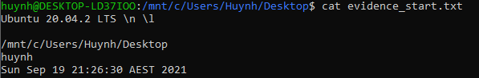

# Q2) Check network Details.

To identify the dns server, check /etc/resolv.conf

Type cat /etc/resolv.conf Is it a public or private address? Private

Take a screen shot for upload.



In your shell, type ip addr . Which interfaces are active? <UP>

* eth0
* lo

What are your active IPv4 addresses?

* 192.168.60.129
* 127.0.0.1

# Q3) Check Processes

An attacker or virus may set up its own process or hijack an existing process.

We use **ps** to show running tasks.

Type ps - - help simple. What do the -a, -A and the -r flags do?

* - -a: All with tty, except session leaders
* - -A: All processes
* - -r: Only running processes

__________________________________

Let us run a suspicious process, say ping.

In another cmd window start another copy of ubuntu.

Ping a dns.

ping 1.1.1.1 the ping should keep pinging.

Switch back to your original ubuntu shell.

Type ps –Af You should see the ping.

Take a screen shot for upload.

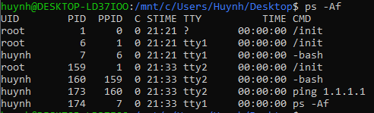

# Q4) Check Services

We can see installed services by looking at init.d,the service launcher.

ls /etc/init.d Take a screen shot for upload.

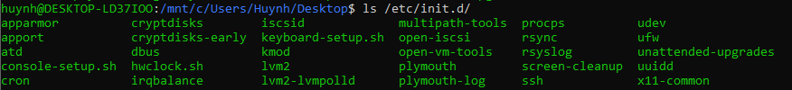

Which ones in the table are running on your device?

* **cron**
* **ssh**
* **x11**

# Part 2: Examine the device non-volatile data

# Q5) System Information – cmd line

5a) The basic system info is revealed by uname

Type uname –a to see the system summary.

Type uname -v to see the kernel version

Type wsl.exe - - update - - status

Take a screenshot of all three for upload.



Comment on the difference shown for the kernel version

* -a prints all the system information in the command uname whereas using -v argument will only print the kernel version which you can see both commands print out the kernel version in their output.

5b) What Linux knows about the hardware is kept in /proc

cat /proc/cmdline # This shows you how the boot image is loaded.

cat /proc/cpuinfo # This shows you the CPU details – some will be virtual if this is a VM.

cat /proc/meminfo # Memory management details

Repeat the cat /proc commands with grep as shown on the lecture slide to show the number of processors, cpu model, total and free Memory. Take a screenshot for upload.



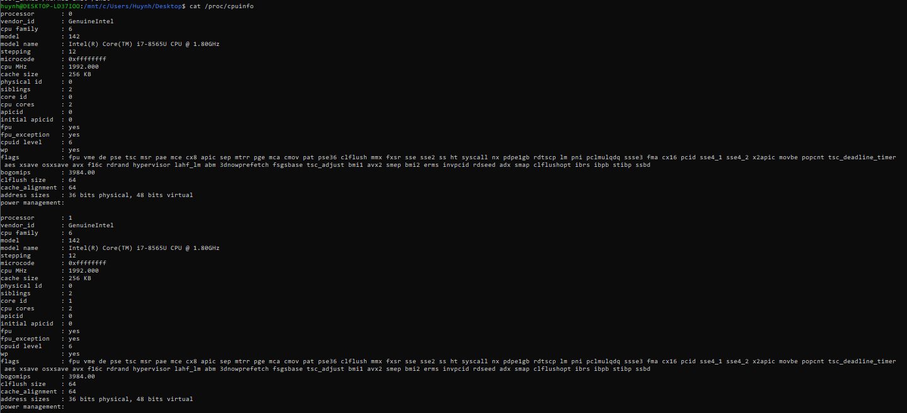

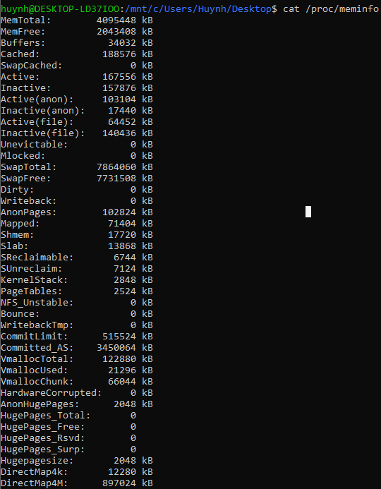

5c) We can see the Linux file structure with df

whatis df?__ Show information about the file system on which each FILE resides, or all file systems by default.

Type df –ahT Take a screen shot for upload

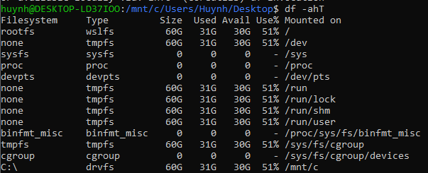

What is the Linux root mount symbol ? /

What is this filesystem type? wslfs

5d) User Accounts

We can see the user accounts in /etc/passwd.

cat /etc/passwd | grep bash

Take a screenshot of the users for your report.



Comment on the results.

There are only 2 users in the system. The root account and my personal account Huynh

Close all windows and shells when done.

# Bring an empty USB for the week 9 Lab.